SECTION KD

CHARGE AIR HEATER/COOLER

CONTENTS

chapter

Description .. .. .. .. .. .. .. .. .. 1

Maintenance and Overhaul .. .. .. .. .. .. .. 2

Chemical Cleaning .. .. .. .. .. .. .. .. 3

Special Tools .. .. .. .. .. .. .. .. .. 4

CHAPTER 1

DESCRIPTION

1. The charge air heater/cooler is bracket mounted to the free-end exhaust manifold. The support bracket also serves as a merge point for ’A' and 'B' bank coolant discharge before the engine coolant thermostat.
2. The charge air heater/cooler consists of a common tubestack/side plate assembly to which are mounted gunmetal headers for sea water supply and discharge and aluminium headers for jacket water supply and discharge. This effectively divides the tubestack into two independent units.
3. The unit is fitted for the following reasons:-
4. To reduce the temperature of air delivered from the turbocharger to the cylinders under normal running conditions. This ensures the maximum amount of air is present in the cylinders at the moment combustion takes place, giving improved power output with economy.
5. If necessary, to re-heat the air delivered from the turbocharger after it has passed through the cooling section of the charge air heater/cooler. This ensures that the temperature of the combustion air is not too low for efficient combustion, minimising the emission of white smoke.
6. Air leaving the turbocharger passes through the sea water cooled cooling section and then through the engine coolant heating section of the charge air heater/cooler.
7. Water from the engine driven sea water pump enters the cooling section through the inlet header, passing through the tubes and leaving through the outlet header to the engine lubricating oil cooler.
8. Jacket coolant on 'A' bank side of the engine, enters a rotary diversion valve controlled by a temperature transmitter mounted on the air inlet pipe to the 'A' bank inlet manifold (refer to Section KA).
9. When the air temperature in the inlet pipe is below 35°C, the valve diverts part or all of the flow of heated jacket coolant through the inlet header, passing through the tubes and leaving through outlet header from where it is returned to the bracket to merge with 'B' bank flow.
10. When the air temperature in the inlet manifold reaches the desired 35-40°C the rotary valve will close cutting off the flow of heated coolant to the heater section.

CHAPTER 2

MAINTENANCE AND OVERHAUL

1. Individual plants operate under such varying conditions it is impossible to lay down hard and fast rules for periodic maintenance or overhaul and only the experience of the engineer in charge and careful noting of performance figures will determine how frequently cleaning and/or overhaul should be carried out.

Maintenance

1. Periodic inspection of tightness of holding down bolts and examination for leaks from air trunking joints and coolant and sea water pipe joints should be made. No further 'On Engine' maintenance is necessary.

Removal and dismantling

1. When it has been determined from performance figures that an internal examination is advisable, the heater/cooler should be removed as follows:-
2. Drain engine cooling system, sea water system and fuel system.
3. Remove cooling system vent piping and brackets from over the top of the heater/cooler.
4. Remove sea water piping to and from fuel oil cooler. Remove fuel oil piping to and from fuel oil cooler. Remove fuel oil cooler.
5. Release and remove piping between sea water pump and charge air heater/cooler and between charge air heater/cooler and oil cooler.
6. Remove coolant bend between diversion valve and inlet header. Remove coolant bend between outlet header and charge air heater/cooler bracket.
7. Remove air piping between turbocharger and charge air heater/cooler and between charge air heater/cooler and air inlet manifolds (see Section LC).

CAUTION DUE TO THE WEIGHT INVOLVED ALL FOUR EYEBOLTS MUST BE FITTED AND USED WHEN LIFTING THE HEATER/COOLER.

1. Screw four Ml6 eyebolts into the tappings on the top plate of the charge air heater/cooler and fit suitable lifting tackle.
2. Release the four setbolts securing the heater/cooler to its bracket and lift away.
3. Remove setscrews and schnorr washers and remove air outlet casing and joint.
4. Remove setscrews, setbolts and schnorr washers and remove air inlet casing and

joint.

1. Remove sea water and coolant headers from both sides of the heater/cooler.
2. No attempt should be made to remove the side plates from the tubestack unless chemical cleaning of the tubes for scale removal is necessary. To remove proceed- as follows:
3. Identify both side plates to the tubestack to ensure correct replacement.
4. Remove securing setscrews and steady bar nuts and remove each side plate from the tubestack. Side plates have a tight spigot engagement with the tubestack and care MUST BE taken to avoid damage to both items during removal. Clean off all jointing compound from mating faces.

Inspection and cleaning

* 1. Check for leaking tubes. Should any tubes be leaking, those in the neighbourhood of the leak should be tested individually in succession a using Tube Tester,(see chapter 4) as follows:-
     1. Hold the rubber bung mounted on a wooden handle at one end of the tube to be tested, apply the tester to the other end, sealing off the tube with its rubber plug.
     2. Charge the tube with compressed air to a pressure of 4.14 bar (60 lb/in2) by depressing the air button for a second or so. The pressure gauge built in the body of the instrument will show the pressure within the tube and if the tube is sound will remain steady, but if leaking very slightly, it will fall rapidly.
  2. If any tubes are leaking, the complete tubestack/sideplate assembly must be renewed.
  3. If all tubes are sound, inspect the tube bores. Where deposits are soft, which will occur in the majority of installations, clean by using special brushes supplied in the Serck tool kit. Rotate the rod in a clockwise direction to avoid unscrewing the brush head from the rod. To speed up cleaning, the rod assembly may be attached to an electric hand drill, but great care must be taken to avoid mechanical damage to the tubes.
  4. If scale is too hard to be removed with a wire brush, the unit should be chemically descaled (see Chapter 3) or returned to the manufacturer or an agent for descaling.
  5. Examine the film plates for deposits. These will gather on the leading edges of the plates and excessive deposits may be removed with a stiff nylon brush (DO NOT use a wire brush).

Assembly and Fitting

NOTE All joints and 'O' rings must befitted dry.

* 1. Apply 'LOCTITE SUPERFLEX SILICONE SEALANT' to sealing faces of one side plate and checking that identification marks are correctly aligned, fit cover to tube stack and fit retaining setscrews and washers. Check side plate air inlet and outlet faces are flush with tube stack faces. Fit steady bars to air inlet and outlet sides of cover.
  2. Apply ’LOCTITE SUPERFLEX SILICONE SEALANT’ to sealing faces of remaining side plate and checking that identification marks are correctly aligned, fit cover to tube stack. Check cover engages correctly with steady bars and air faces are flush with tube stack faces. Secure with setscrews, washers and nuts.
  3. Using new nitrile rubber joints, fit sea water and coolant headers to the tubestack and pressure test both sides to a pressure of 4.13 bar (60 lb/in2).
  4. Using new joints fit air inlet and outlet casings to the heater/cooler and pressure test to a pressure of 3.45 bar (50 lb/in2).

CAUTION DUE TO THE WEIGHT INVOLVED ALL FOUR EYEBOLTS MUST BE FITTED AND USED WHEN LIFTING THE HEATER/COOLER.

* 1. Screw four M16 eyebolts into the tappings on the top plate of the heater/cooler and fit suitable lifting tackle.
  2. Lift the heater/cooler into position on its mounting bracket and secure with M16 setbolts and plain washers.
  3. Refit all air, coolant, sea water, fuel and vent piping and vent all systems.

CHAPTER 4

CHEMICAL CLEANING

1. If scale on the tubestack cannot be removed by normal cleaning it will be necessary to remove the scale by chemical means.
2. Remove the charge air heater/cooler as described in Chapter 2.
3. Remove inlet and return headers and side plates (see paras 2.6 and 2.7).
4. The tubestack can now be immersed, first to clean the film plates and then the tubes.

Air side

1. To clean the film plates, immerse the stack in a tank containing a solution made from H.D. DEGREASANT POWDER manufactured by:-

Houseman and (Burnham) Limited  
Cambridge House  
Cambridge Road  
Bedford  
MK42 OLN

1. D. powder is non-toxic and non-flammable. It is most effective when used in solution as near boiling point as possible. Either steam or electric heaters may be used to heat the water. The degreasant powder should be added to the boiling water (never vice versa). Agitation of the solution will assist the washing process.
2. Other degreasants may be used at the discretion of the engineer in charge, eg. BASOL 77 in crystal form manufactured by:-

Basol limited  
Malt House  
Moor Lane  
Staines  
Middlesex

INDUSTRIAL CLEGRIS manufactured by:-

Clensol Limited  
40 Berkeley Square  
London. W1

H.D.S. phenol based degreasant manufactured by:-

Houseman (Burnham) Limited

Water Side

1. To clean the tubes internally if the scale is hard and too difficult to remove with a wire brush, Serck's recommend the use of H.T.L. solution which is an inhibited acid solvent manufactured by Houseman and Thompson Limited.

WARNING NEVER ADD WATER TO ACID, ALWAYS ADD ACID TO WATER.

1. Add the acid to the water to give a solution strength of 1 part H.T.L. to 8 parts of fresh water. Heat the diluted acid to 120°F and immerse the cooler stack in the tank, observing the effervescence which indicates that the scale is dissolving. If the effervescence ceases before all the scale is removed it will be necessary to repeat the process with the acid strength increased to 1 part H.T.L. to 7 parts of fresh water, heating as before. This should remove any scale remaining.
2. When it is seen that effervescence has ceased and no more scale remains, the cooler stack should be taken out of the tank and any further action of the acid neutralised by immersion in a tank containing soda crystals at the ratio of 1 pound to every 5 gallons of boiling fresh water.
3. Other acid solvents may be used, eg., 'CLENSOL' or inhibited hydrochloric (muriatic) acid, at the discretion of the engineer in charge. The makers instructions should be followed and care must be taken to prevent aluminium parts coming into contact with the acid.

CHAPTER 4

SPECIAL TOOLS

The following special tools are sufficient for carrying out all general maintenance, dismantling, overhaul and assembly operations on the cylinder head as detailed in this section.

NOTE These tools are only shown in the Illustrated Parts List if they have been ordered as part of the contract.

|  |  |  |
| --- | --- | --- |
| DESCRIPTION | PART NO | USE |
| Tube tester  Tool Kit | MZ.8487/2  OD30469 | For testing tubes for leakage  For cleaning charge air heater/cooler tubestack |

Key To Numbers

1. Coolant outlet
2. Sea water inlet
3. Joint
4. Tubestack assembly
5. Setbolt top cover
6. Joint
7. Stud
8. Nut
9. Sea water outlet
10. Coolant inlet from turbocharger/diversion valve
11. Joint
12. 'O' ring
13. Charge air heater/cooler bracket
14. Coolant inlet from diversion valve
15. 'O' ring
16. Coolant outlet to thermostat
17. 'O' ring
18. Setbolt bracket to charge air heater/cooler
19. Coolant inlet from charge air heater/cooler
20. Setbolt, bracket to exhaust manifold
21. Setbolt, bracket to exhaust manifold
22. Joint

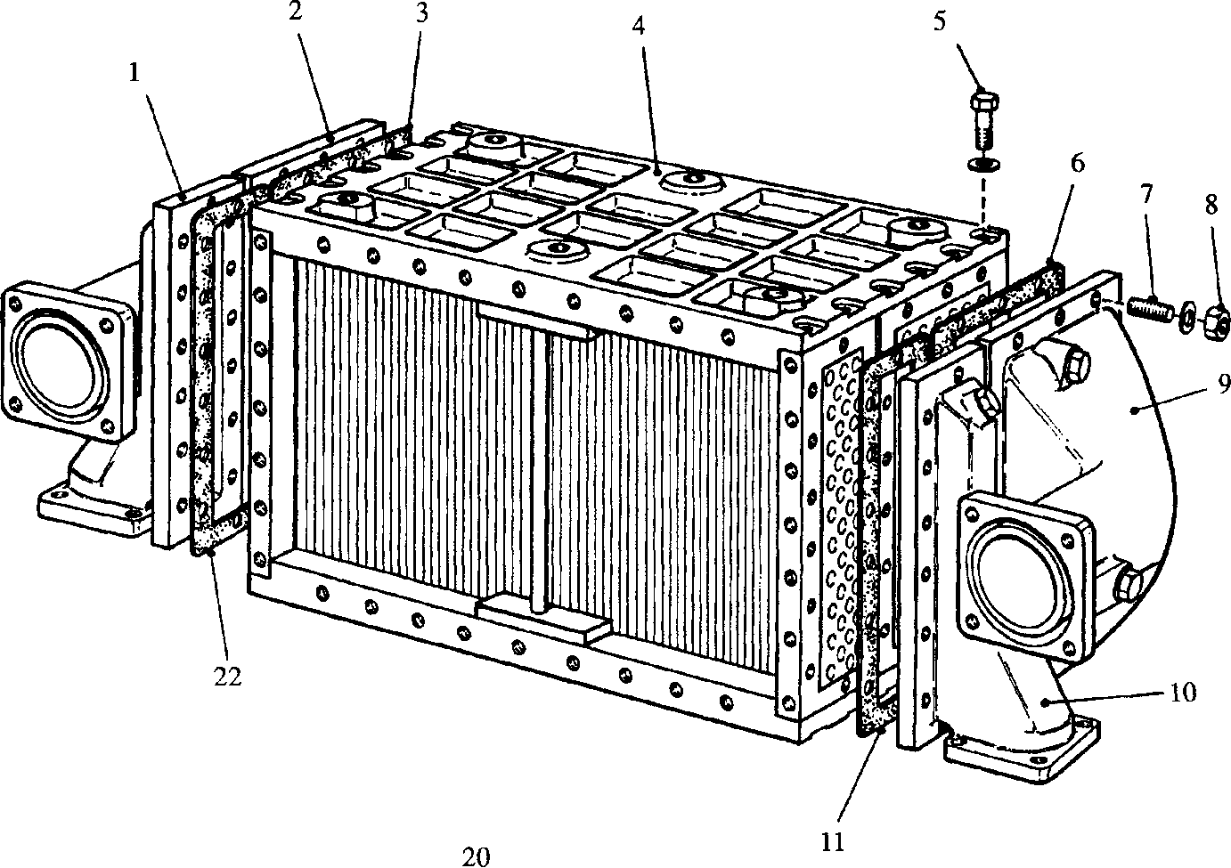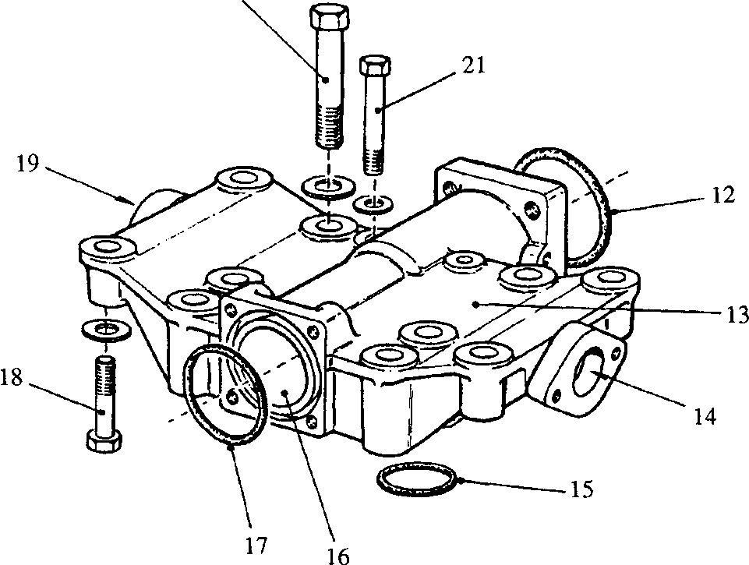

**SPD00504**

**Fig KD.l Charge air heater/cooler**